NATIONAL OPEN UNIVERSITY OF NIGERIA
14-16 AHMADU BELLO WAY, VICTORIA ISLAND LAGOS
MARCH/APRIL 2016 EXAMINATION

SCHOOL OF SCIENCE AND TECHNOLOGY

COURSE CODE: CHM391
COURSE TITLE: PRACTICAL CHEMISTRY V – INORGANIC AND ANALYTICAL

TIME: 2 HOURS
INSTRUCTION: ANSWER ANY FOUR QUESTIONS

QUESTION ONE

- Use a schematic diagram to show the procedure for the separation and identification of a metal cation in a given sample by qualitative inorganic analysis of cation method.

10¹/₂ marks

- Differentiate between qualitative analytical groups and groups of the periodic table.
7 marks

QUESTION TWO

- Below is an infrared spectrum of an unknown organic compound. Using the table of the characteristic infrared absorption bands of organic functional groups provided below, identify the functional groups present in this organic compounds.

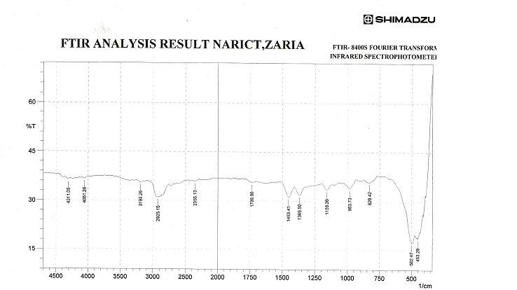

Table : CHARACTERISTIC INFRARED ABSORPTION BANDS OF FUNCTIONAL GROUPS
Class of compounds | Absorption cm⁻¹ | Intensity | Assignment
Alkanes and Akyls  Alkenes  Alkynes  Ethers  Aldehydes  Carboxylic acids  Alcohols | 2850 – 3000  1450 – 1470  1370 – 1390  1365 +1395  Two bands  715 - 725  3020-3140  1640-1670  910+990  Two bands  885-895  665-730  960-980  790-840  3265-3335  2100-2140  610-700  2190-2260  1085-1150  1020-1075 and  1200-1275  (Two bands)  2700-2725  1720-1740  1685-1710  2500-3500  1710-1715  1680-1710  3300 – 3400  1125 - 1205 | s  s  m  m  w  w-m  vw-m  m+s  s  m-s, broad  s  s  s  m  s  vw-w  s  m  m  s  s  s bend  s, broad  s, broad  s, broad  m - s | C – H stretch  C- H bend  CH_{2,} C – H bend  -CH(CH₃)₃ bend  -(CH₂)n bend  =C-H Stretch  C=C Stretch  =C-H bend  =C-H bend  =C-H bend  =C-H bend  =C-H bend  =C-H Stretch  C=C Stretch  =C-H bend  C=C Stretch  C-O-C Stretch  =C-O-C sym and asym stretch  H-C=O Stretch  C=O Stretch  C=O Stretch  O-H Stretch  C=O Stretch  C=O Stretch  O – H stretch  C –O stretch

Intensity abbreviations: vw = very weak, w = weak, m = medium, s = strong, vs = very strong

9 marks
- Explain briefly the principle of infrared Spectroscopy

8¹/₂marks

QUESTION THREE

- A laboratory analysis was conducted to determine the amount of aspirin (2-acetylbenzoic acid) in a commercial aspirin product using UV-Visible Spectroscopic method. The commercial aspirin was complexed with sodium hydroxide and iron (iii) Solution to form the salicylate dianion (the intensity of the colour of the complex is directly related to the concentration of aspirin present) and the absorbance of this complex determined. Five series of solutions with different aspirin concentrations was prepared and labeled A-E and complexed. The absorbance of each solution was measured. Using the information below

- Construct a calibration curve
- Use the calibration curve to determine the amount of aspirin in the commercial aspirin product

Concentrations of standard solution (mg/ml) | Absorbances of standard solution | Standard solutions
0.05 | 0.2 | A
0.10 | 0.4 | B
0.15 | 0.6 | C
0.20 | 0.8 | D
0.25 | 1.0 | E

The absorbance of the commercial aspirin product is 0.5
17¹/₂ marks

QUESTION FOUR
.
- Write briefly on the principle of Atomic Absorption Spectroscopy

8 marks

- The concentration of magnesium in tap water is to be determined by employing Atomic Absorption Spectroscopy (AAS) to measure the absorbance of magnesium in tap water. A set of standard solutions of magnesium was prepared and their absorbance obtained. Prepare a calibration curve of the magnesium standard solutions and determine from the calibration curve the concentration of magnesium in the tap water. The absorbance of the magnesium in the tap water read 0. 2

Concentration of magnesium standard solutions (PPM) | Absorbance of magnesium standard solutions
2.50 | 0.2
4.500 | 0.3
6.500 | 0.5
8.500 | 0.7
10.500 | 0.9

9¹/₂ marks

QUESTION FIVE

- In an analysis to determine the chloride present in a given sample weighing 1.52g by precipitation gravimetric method, aqueous solution of the sample was acidified with dilute acid and a slight excess of silver nitrate solution was added, whereupon the chloride present in the sample was precipited as silver chloride. If the weight of the silver chloride precipitate obtained is 0.126 g, calculate the percentage of chloride in the sample. Gravimetric factor = Cl/Agcl =0.24737

9 marks
- What is digestion of a precipitate and why is it necessary

8¹/₂ marks

QUESTION SIX

- The concentration of an organic compound is to be determined from its calibration curve by UV-visible spectroscopy, if the wavelength of maximum absorption (λ max) of this compound is unknown, determine the wavelength of maximum (λ max) at which the calibration curve can be prepared using the information provided below.

Absorbance(s) of the organic compound | Wavelengths of absorption of the organic compound (nm)
0.100 | 360
0.110 | 380
0.120 | 400
0.125 | 420
0.130 | 440
0.16 | 460
0.165 | 480
0.400 | 500
0.60 | 520
1.00 | 540
1.10 | 560
0.80 | 580
0.40 | 600
0.10 | 620
0.11 | 640
0.12 | 660

10marks

- Describe briefly the principle of UV-visible spectroscopy
7¹/₂ marks.

