NATIONAL OPEN UNIVERSITY OF NIGERIA
14-16 AHMADU BELLO WAY, VICTORIA ISLAND LAGOS
MARCH/APRIL 2016 EXAMINATION

SCHOOL OF SCIENCE AND TECHNOLOGY

COURSE TITLE: CIT341
COURSE TITLE: DATA STRUCTURES

Time: 3 HOURS
INSTRUCTION: Answer any five questions out of Seven

1.
  - Briefly explain the difference between linear and non-linear data structures.
  - Write a brief note on each of the following:
    - List
    - Array
  - Distinguish between a stack and a queue making sure to illustrate your answer.

  - Consider the following operations carried out on a queue Q. Provide the content of the queue and the returned value, after each operation, to complete the table.
Operation | Content of Q | Returned Value
Initialise(Q)
Add(D,Q)
Add(A,Q)
Add(O,Q)
Remove(Q)
Add(T,Q)
Remove(Q)
  - Using a simple example explain the process of storing a queue in a dynamic data structure illustrating how a node can be added and removed.
  - Explain briefly two modes of stack storage.

  - Explain clearly what a hash function is.
  - Write down three characteristics of a good hash function.
  - Briefly describe what a hash table is giving an example of its application.

  - Briefly describe the mathematical definition of a tree giving its salient properties.
  - Explain the recursive nature of the definition of a tree.
  - Using an example describe the inverted pictorial representation of a tree.

  - Briefly describe what a search tree is listing its main properties.
  - Concisely define what a perfect binary tree is.
  - Using the simple tree shown in the figure below as an example, describe the following traversal methods:
    - Preorder
    - In order
    - Postorder
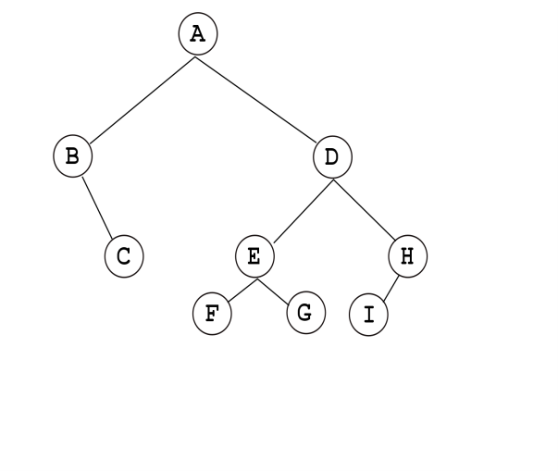

  - Briefly explain the concept of garbage accumulation in a Java Programme
  - Write short notes on the following garbage collection techniques
    - Reference Counting
    - Mark-and-Sweep
  - Briefly describe four Memory Allocation methods.

  - Explain clearly what greedy algorithm is.
  - Describe four functions of greedy algorithm
  - Briefly describe the three phases of the divide-and-conquer paradigm.

