NATIONAL OPEN UNIVERSITY OF NIGERIA
14/16 AHMADU BELLO WAY, VICTORIA ISLAND, LAGOS
SCHOOL OF SCIENCE AND TECHNOLOGY
JUNE/JULY EXAMINATION

COURSE CODE: CIT322
COURSE TITLE: INTRODUCTION TO INTERNET PROGRAMMING (3UNITS)
TIME ALLOWED: 2¹/₂HOURS
INSTRUCTION: ANSWER ANY FOUR QUESTIONS IN ALL

  - State the meaning of the following search terminologies (10.5 points)
    - Search tool
    - Metasearch engine
    - Query
    - Query Syntax
    - Query Semantic
    - Hit
    - Relevancy score

  - Write the HTML code to display the following table (with headers Name and Gender)
(7 points)
Name | Gender
John | Male
Mercy | Female

  - Write the HTML code to display the following table (with headers Col1, Col2, Col3, Col 4)
(7.5 points)
Col1 | Col2 | Col3 | Col4
Data |  | Information
Header
Footer

2b. Write short note on the origin of Internet (10 points)

3a. Differentiate between the Internet, Extranet and Internet. (12 points)
3b. Write a simple line HTML tag that will enable a user to navigate from the present site to NOUN site. (5.5 points)

4a. Write a HTML code snippet using CSS to display the Output below: (8.5 points)
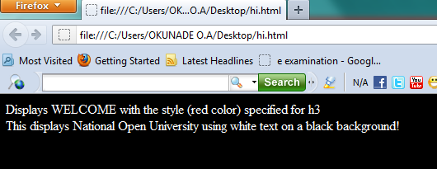
4b. Differentiate in tabular form, the diffences between the three Components of a Search Engine (9 points)
5a. Differentiate between Colspan and RowspanAttributes (10 points)
5b. Explain and write a syntax for If...else Statement (7.5 points)

6a. Write short note on the following three Communication Protocols. (7.5 points)
i. User Datagram Protocol
ii. Hypertext Transfer Protocol (HTTP)
iii. Email Protocols
6b. Write a HTML code snippet that will display the output shown below:(10 points)
