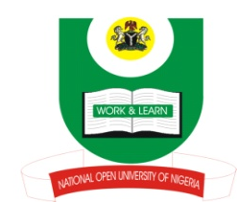

NATIONAL OPEN UNIVERSITY OF NIGERIA
14-16 AHMADU BELLO WAY, VICTORIA ISLAND, LAGOS
SCHOOL OF ARTS AND SOCIAL SCIENCES
JUNE/JULY 2013 EXAMINATION

COURSE CODE: :CTH 441
COURSE TITLE: WEST AFRICAN CHURCH HISTORY
TIME ALLOWED: 2HRS
INSTRUCTIONS: ANSWER QUESTION ONE IN SECTION A AND ANY TWO IN SECTION B (SECTION A CARRIES 30 MARKS, WHILE SECTION B CARRIES 20 MARKS EACH)

SECTION A

- Account for the contributions of the British Parliament in the Abolition of Slave Trade in Nigeria.
SECTION B
- Discuss the role played by the Yoruba settlers in both Freetown and Sierra –Leone in the spread of Christianity in West Africa.

- State how the Roman Catholic Church was established in Ghana.

- Enumerate the duties of the Church Missionaries in Sierra - Leone.

- List the difficulties faced by the early Missionaries in West Africa.

