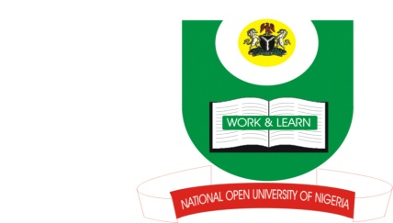
NATIONAL OPEN UNIVERSITY OF NIGERIA
14-16 AHMADU BELLO WAY, VICTORIA ISLAND, LAGOS
SCHOOL OF ARTS AND SOCIAL SCIENCES
JUNE/JULY 2013 EXAMINATION

COURSE CODE: ENG 432
COURSE TITLE: PRAGMATICS
TIME ALLOWED: 2HRS
INSTRUCTIONS: ANSWER THREE (3) QUESTIONS IN ALL.
QUESTION FIVE (5) IS COMPULSORY.

- Write short notes with examples on any two(2) of the following:
- Semantics versus Pragmatics
- Utterance meaning versus Sentence meaning
- Reference versus Inference

2. Identify the pragmatic function of the underlined word in the following:
- FCMB-Because you deserve it (advert)
- Etisalat-now you’re talking (advert)
Identify the presuppositions in the following:
- The man started thinking of getting married after he got a good job
- The pilot managed to land the faulty airplane safely on ground

- a. Evaluate the adequacy of the addressee’s response to the request in the dialogue below based on Grice’s conversational maxims.
Student (speaker): Good morning, sir. I have come to see you.
Lecturer (Addressee): I am coming (The lecturer is on his way out of his office)
b. State and explain the implicature and explicature of the response.

- Imagine you are in a bank to withdraw some money and two people walk up to you one after the other. The first one says:
Sweetheart, can I use your pen?
And the second one says
Please ma, let me use your pen.
- Mention 2 factors that determine the politeness strategies used by the two speakers.
- Based on these factors, what assumptions would you make if you were addressed in these two ways?

- a. Identify and explain the locutionary, illocutionary and perlocutionary acts associated with MTN’s advertising slogan, ‘I don port’.
- Based on Searle’s (1976) classification, what type of act is it?

