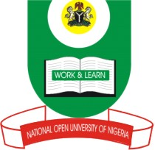

NATIONAL OPEN UNIVERSITY OF NIGERIA
14/16 AHMADU BELLO WAY, VICTORIA ISLAND, LAGOS
SCHOOL OF SCIENCE AND TECHNOLOGY
JUNE/JULY EXAMINATION

COURSE CODE: HEM 704
COURSE TITLE: Basic Anatomy and Physiology of Human Body(2 units)
TIME ALLOWED:2 hours
INSTRUCTION: Answer any 4 questions

Question 1:
Define anatomy and explain its divisions (25 marks)

Question 2
Describe the process of blood circulation within the human heart (25 marks)

Question 3
Define Physiology and explain its divisions (25 marks)

Question 4
What are the functions of the skeletal system (25 marks)

Question 5
Describe the features of the human brain (25 marks)

Question 6
What are the features and attributes of the human blood? (25 marks)

