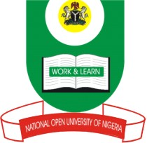
NATIONAL OPEN UNIVERSITY OF NIGERIA
14/16 AHMADU BELLO WAY, VICTORIA ISLAND, LAGOS
SCHOOL OF SCIENCE AND TECHNOLOGY
JUNE/JULY EXAMINATION

COURSE CODE: HEM 706
COURSE TITLE: Alcohol, Drug and HIV/AIDS
TIME ALLOWED: 3 hours
INSTRUCTION: Read the questions carefully. You have seven questions to answer five. Allquestions carry equal marks (14%) each.

Question 1
- What are the consequences of alcoholism?(8 marks)
- List the factors that influence adolescents to take to drinking alcohol. (6 marks)

Question 2
- List all short and long term effects of alcoholism you know.(14marks)

Question 3
- Classify binge drinking.(3 marks)
- Identify the ingredients present in tobacco.(11 marks)

Question 4
- What are the major alcoholic drinks in Nigeria?(5marks)
- List the short-term effects of tobacco use. (5marks)
- What is the major drawback of rapid smoking therapy? (4marks)

Question 5
- List the various types of drugs available? (3 marks)
- Discuss Psychoactive Drugs (11marks)

Question 6
- List the various categories of drug users. (3marks)
- Differentiate between the various categories of drug users.(11marks)

Question 7
- List 4 venereal diseases according to Arya, et al. 1998. (2marks)
- Discuss psychoactive drugs (12marks)

