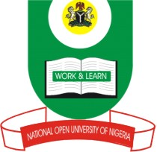
NATIONAL OPEN UNIVERSITY OF NIGERIA
14/16 AHMADU BELLO WAY, VICTORIA ISLAND, LAGOS
SCHOOL OF SCIENCE AND TECHNOLOGY
JUNE/JULY EXAMINATION

COURSE CODE: HEM726
COURSE TITLE: Clinical, Diagnostic and Therapeutic Services in HIV/AIDS (2Units)
TIME ALLOWED:2hours
INSTRUCTION: There are six questions to answer four. All questions carry equal marks (17.5%)
each

Question 1
a. What is HIV/AIDS? (3.5marks)
b.How does HIV replicate in human body?(14marks)

Question 2
a. What are the major causes of HIV infection? (7 ½ marks)
b.Listseven HIV/AIDS at risk group.(10 marks)

Question 3
a. Discuss the types of HIV culture tests you know and their disadvantages(17.5 marks)

Question 4
a. List the steps of HIV Life cycle.(4marks)
b. Discussthe two types of acquired immunity? (13.5marks)

Question 5
a. Draw and label the diagram of HIV structure. (17.5marks)

Question 6
a. What is an opportunistic infection? (3.5marks)
b. List the major opportunistic infections. (15marks)

