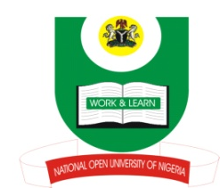

NATIONAL OPEN UNIVERSITY OF NIGERIA
14-16 AHMADU BELLO WAY, VICTORIA ISLAND, LAGOS
SCHOOL OF ARTS AND SOCIAL SCIENCES
JUNE/JULY 2013 EXAMINATION

COURSE CODE: INR332
COURSE TITLE: WAR AND PEACE IN WEST AFRICA SINCE 1960
TIME ALLOWED:2HRS
INSTRUCTIONS: ANSWER ANY THREE (3) QUESTIONS

1. Different between the colonial policies of assimilation and indirect rule in West Africa

2. (a) What is mediation?
(b) Discuss any five (5) mediation processes

3. Although similar, ‘conflict resolution’ and ‘conflict suppression’ are also different. What are the differences and similarities between the two?

4. What are the current problems facing the Economic Community of West African States?

5. Discuss five (5) major causes of conflicts in the English-Speaking West African Countries since independence?

