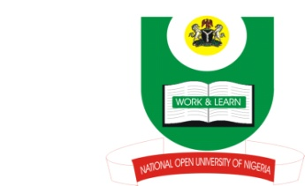

NATIONAL OPEN UNIVERSITY OF NIGERIA
14-16 AHMADU BELLO WAY, VICTORIA ISLAND, LAGOS
SCHOOL OF ARTS AND SOCIAL SCIENCES
JUNE/JULY 2013 EXAMINATION

COURSE CODE: INR351
COURSE TITLE: EUROPE IN WORLD POLITICS
TIME ALLOWED:2HRS
INSTRUCTIONS: ANSWER 3 QUESTIONS IN ALL

- How would you describe Europe and why is it difficult to precisely determine the boundaries of Europe? (23 Marks)

- How did industrial advances lead to militarism in Europe in the late 19th and early 20th century? (23 Marks)

- In what way was the treaty of Versailles responsible for the outbreak of the Second World War? How did the final battles of the Second World War contribute to the division of Europe between East and West by 1945? (23 Marks)

- The Napoleonic period is often described as France’s finest period as a European power. Discuss. (23 Marks)

- What characteristics make Germany a leader in Europe? (23 Marks)

