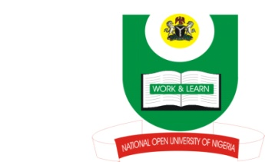

NATIONAL OPEN UNIVERSITY OF NIGERIA
14-16 AHMADU BELLO WAY, VICTORIA ISLAND, LAGOS
SCHOOL OF ARTS AND SOCIAL SCIENCES
JUNE/JULY 2013 EXAMINATION

COURSE CODE: INR 412
COURSE TITLE: INTERNATIONAL RELATIONS OF THE GREAT POWERS
TIME ALLOWED: 3HRS
INSTRUCTIONS: ANSWER 4 QUESTIONS IN ALL

1. In a rapidly globalising world, it is difficult for states to claim exclusive rights and responsibilities over foreign policies. Discuss this in the light of dynamism of globalisation. (17 Marks)
2. Discuss the impacts of the two world wars on traditional principles of British foreign policy. (17 Marks)
3. Assess the impact of the Second World War on the decolonization process in the British Empire (17 Marks)
4. Examine the factors that gave rise to French’s La Francophonie policy in Africa after decolonisation and evaluate the impact of the policy in Africa (17 Marks)
5. To what extent is it true to state that the principles of Soviet Union’s foreign policy were hinged on geographical location and ideology? (17 Marks)
6. How relevant are the Chinese’s five principles of peaceful co-existence in contemporary international relations (17 Marks)

