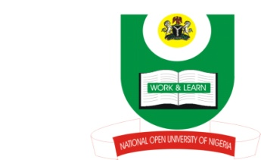

NATIONAL OPEN UNIVERSITY OF NIGERIA
14-16 AHMADU BELLO WAY, VICTORIA ISLAND, LAGOS
SCHOOL OF ARTS AND SOCIAL SCIENCES
JUNE/JULY 2013 EXAMINATION

COURSE CODE: INR431
COURSE TITLE: INTERNATIONAL RELATTIONS OF THE FRANCOPHONE WEST AFRICA
TIME ALLOWED:2HRS
INSTRUCTIONS: ANSWER 3 QUESTIONS IN ALL

- Examine in detail the assimilation and association policies in French West Africa. (23 Marks)

- “The Anglo-French rivalry deterred the success of French policy in Porto Novo.” Do you agree? (23 Marks)

- Analyse the reasons for France’s strategic dependence on French West Africa after the World War II. (23 Marks)

- Give an account of the reasons responsible for ineffectiveness in the existence of regional organizations in French West Africa. (23 Marks)

- “French Commonwealth was inevitable in French West Africa.” Discuss. (23 Marks)

