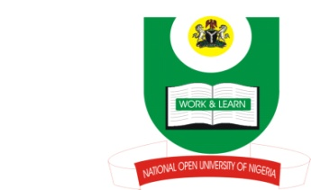

NATIONAL OPEN UNIVERSITY OF NIGERIA
14-16 AHMADU BELLO WAY, VICTORIA ISLAND, LAGOS
SCHOOL OF ARTS AND SOCIAL SCIENCES
JUNE/JULY 2013 EXAMINATION

COURSE CODE: ISL339
COURSE TITLE: ISLAMIC FAMILY LAW
TIME ALLOWED: 2HRS
INSTRUCTIONS: ANSWER ONLY THREE QUESTIONS IN ALL

- Analyze the preliminaries of marriage and discuss the requirements of marriage. (23Marks)
- Evaluate and criticize the wisdom behind the prohibited degrees of marriage. (23Marks)

- Do you believe that Muslims should engage in marriage with Christian ladies in our contemporary Nigerian society? Give reasons for your answer. (23 Marks)

- Evaluate the role of a husband as the protector and maintainer (Qawwām) of the house. (23 Marks)

- Family planning and birth control is a controversial issue in Islam. Discuss. (23 Marks)

