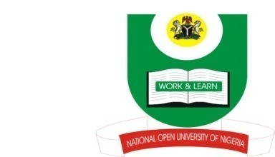

NATIONAL OPEN UNIVERSITY OF NIGERIA
14-16 AHMADU BELLO WAY, VICTORIA ISLAND, LAGOS
SCHOOL OF ARTS AND SOCIAL SCIENCES
JUNE/JULY 2013 EXAMINATION

COURSE CODE: ISL373
COURSE TITLE: ISLAM IN SPAIN
TIME ALLOWED:2HRS
INSTRUCTIONS: ANSWER ONLY THREE QUESTIONS

- Portray the socio-political milieu of Egypt and North Africa before the Muslim conquests in the sub-region. (23 Marks)
- Mention the major Muslim commanders who were instrumental to the ultimate conquest of North Africa, and recount their expeditions. (23 Marks)
- Almoravids and Almohads Islamic movements greatly influenced the Islamization of North Africa. Discuss. (23 Marks)
- Mention and explain some of the factors responsible for the Muslim conquests in Spain. (23 Marks)
- Identify factors in Islamic civilization that fostered a tradition of learning and its spread in Muslim Spain. (23 Marks)

