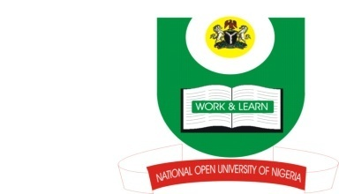

NATIONAL OPEN UNIVERSITY OF NIGERIA
14-16 AHMADU BELLO WAY, VICTORIA ISLAND, LAGOS
SCHOOL OF ARTS AND SOCIAL SCIENCE
JUNE/JULY 2013 EXAMINATION

COURSE CODE: ISL447
COURSE/TITLE: ISLAM AND INTER-RELIGIOUS DIALOGUE
TIME ALLOWED: 2 HRS
INSTRUCTIONS : ANSWER ONLY THREE QUESTIONS IN ALL

- What is Inter-Religious Dialogue and why do you think it is necessary among religious scholars and students? (23 Marks)

- Why do you think Muslims and Christians should understand one another on matters relating to Prophet Isa and his mother, Maryam? (23 Marks)

- Discuss proselytization and religious bigotry as part of factors militating against effective dialoging among religious people in Nigeria. (23 Marks)

- To what extent do you believe religion has been commercialized in Nigeria? (23Marks)

- Examine the activities of Supreme Council for Islamic Affairs (SCIA) and the Christian Association of Nigeria (CAN) as veritable agents for the promotion of inter-religious dialogue in Nigeria. (23 Marks)

