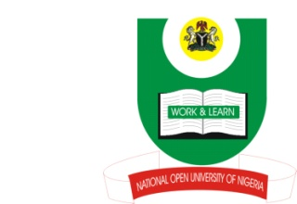

NATIONAL OPEN UNIVERSITY OF NIGERIA
14-16 AHMADU BELLO WAY, VICTORIA ISLAND, LAGOS
SCHOOL OF ARTS AND SOCIAL SCIENCES
JUNE/JULY 2013 EXAMINATION

COURSE CODE: JLS 713
COURSE TITLE: MEDIA AND SOCIETY
TIME ALLOWED: 3HRS
INSTRUCTIONS: ANSWER ANY FOUR QUESTIONS

QUESTION 1:
The Media are the vehicles for message conveyance.
(a) Give an in-depth definition of the mass media. 10 marks
- What are the characteristics of mass media? 15 marks

QUESTION 2:
The fact that the mass media are off-shoot of traditional communication even though they are complex and sophisticated in technology and have a wide reach than trado-communication. Explain the relationship between trado-media and the mass media. 25 marks

QUESTION 3
(a) Give an in depth definition of communication. 10 marks
(b)Mention and discuss three types of communication that you know. 15marks

QUESTION 4
Apart from the traditional or conventional functions of the mass media, i.e.to inform, educate and entertain, the mass media also perform other numerous functions. Mention and discuss four of such functions of the mass media. 25 marks

QUESTION 5 Whatare the differences betweenthe Authoritarian and Libertarian theories of the mass media? Cite instances of countries they are currently operational. 25 marks

QUESTION 6
In mass media, the classification is carried out according to the medium involved in the process of conveying messages.
- Explain the various classifications of mass media. 10 marks
- Highlight and discuss at least four areas where print and electronic media differs.15 marks

