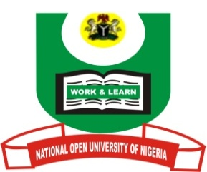
NATIONAL OPEN UNIVERSITY OF NIGERIA
14-16 AHMADU BELLO WAY, VICTORIA ISLAND, LAGOS
SCHOOL OF ARTS AND SOCIAL SCIENCES
JUNE/JULY 2013 EXAMINATION

COURSE CODE: MAC 427
COURSE TITLE: ECONOMIC AND SOCIAL ISSUES IN ADVERTISING AND PUBLIC RELATIONS
TIME ALLOWED:2HRS
INSTRUCTIONS: ANSWER QUESTION ONE WHICH IS COMPULSORY WITH ANY OTHER TWO.

- Amongst the various roles of advertising, it plays an economic role. Discuss five of these roles. (15 marks)
(b) List and explain five types of advertising. (15 marks)

- List and explain five stages of an advertising campaign. (20 marks)

- Public Relations is a management function. Discuss briefly. (10 marks)
(b) Give five roles of Public Relations in management. (10 marks)

- What is a marketing mix? (4 marks)
(b) Discuss the four components of the marketing mix. (16 marks)

- Discuss in full the concept of Press Relations. (10 marks)
(b) Give a detailed explanation of “Letters to the Editor” (10 marks)

