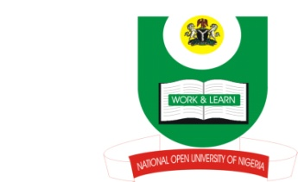
NATIONAL OPEN UNIVERSITY OF NIGERIA
14-16 AHMADU BELLO WAY, VICTORIA ISLAND, LAGOS
SCHOOL OF ARTS AND SOCIAL SCIENCES
JUNE/JULY 2013 EXAMINATION

COURSE CODE: PCR311:
COURSE TITLE: PHILOSOPHIES AND GREAT PERSONALITIES OF PEACE
TIME ALLOWED: : 3HRS
INSTRUCTIONS: ANSWER ANY THREE QUESTIONS

- Discuss four philosophical approaches to conflict resolution? (23mks)

- ‘Great Personalities of Peace could only effectively invoke philosophical dispositions to resolve conflict when adequately protected by certain aspects of both municipal and International Laws’. Discuss (23mks)

- What do you understand by African Philosophy? Relate African Philosophy to three events in the African continent, citing Case Studies. (23mks)

- What is Western Philosophy? Discuss the work of St.Augustine as an important Western Philosopher. (23mks)

- Examine the political philosophies of Sekou Toure and Hellen Johnson Sirleaf, and lessons learned for enduring peace in Africa. (23mks)

(1Mark for good expression)

