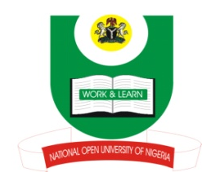
NATIONAL OPEN UNIVERSITY OF NIGERIA
14-16 AHMADU BELLO WAY, VICTORIA ISLAND, LAGOS
SCHOOL OF ARTS AND SOCIAL SCIENCES

JUNE/JULY 2013 EXAMINATION

COURSE CODE: PCR 417:
COURSE TITLE: INTERNATIONAL RELATIONS AND SECURITY
TIME ALLOWED: 3HRS
INSTRUCTIONS: ANSWER ANY THREE QUESTIONS. TIME ALLOWED

1.a. What is the international system? (3mks)
b. Examine the growth of international system. (20mks)

2. How would you examine the basic features of a political power? (23mks)

3. Examine the nature and gradual evolution of international organization. (23mks)

4. State and explain the basic features of diplomacy. (23mks)

5. How would you examine the nature of integration theory? (23mks)

(1Mark for good expression)

