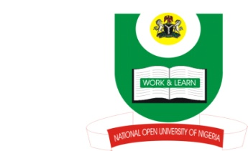
NATIONAL OPEN UNIVERSITY OF NIGERIA
14-16 AHMADU BELLO WAY, VICTORIA ISLAND, LAGOS
SCHOOL OF ARTS AND SOCIAL SCIENCES
JUNE/JULY 2013 EXAMINATION

COURSE CODE: PCR 422
COURSE TITLE: GLOBALIZATION AND PEACE
TIME ALLOWED: 3HRS
INSTRUCTIONS: ANSWER ANY THREE QUESTIONS

- How can multi-lateralism and pluralism promote peace in the age of globalization? (23mks)

- What do you understand by Globalization? Discuss three perspectives to understanding globalization. (23mks)

- Identify and discuss the driving forces or elements of globalization. (23mks)

- Outline and discuss the various dimensions of globalization. (23mks)

5) What in your opinion should Africa do to maximize benefits from globalization? (23mks)

(1Mark for good expression)

