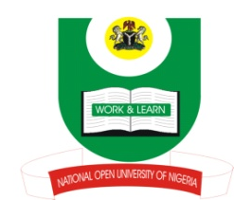
NATIONAL OPEN UNIVERSITY OF NIGERIA
14-16 AHMADU BELLO WAY, VICTORIA ISLAND, LAGOS
SCHOOL OF ARTS AND SOCIAL SCIENCES
JUNE/JULY 2013 EXAMINATION

COURSE CODE: PCR712
COURSE TITLE: DEMOCRACY AND GOOD GOVERNANCE
TIME ALLOWED: 3HRS
INSTRUCTIONS: ANSWER ANY THREE QUESTIONS

- Corruption has become a cancerous growth that has eaten deep into the fabric of the Nigerian society. Advance reasons for this and proffer the way forward.(23mks)

- Of what importance is true democracy to the society? Explain. (23mks)

- “Accountability, democracy and good governance are birds of a feather that flock together.” Discuss. (23mks)

- “Constitution is the “holy book” on which true democracy is anchored.” How and why? (23mks)

- Should centralization of political and economic powers be encouraged or discouraged under democratic settings? Discuss. (23mks)

(1Mark for good expression)

