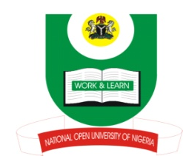
NATIONAL OPEN UNIVERSITY OF NIGERIA
14-16 AHMADU BELLO WAY, VICTORIA ISLAND, LAGOS
SCHOOL OF ARTS AND SOCIAL SCIENCES
JUNE/JULY 2013 EXAMINATION

COURSE CODE: PCR 817
COURSE TITLE: THEORIES OF PEACE EDUCATION AND CONFLICT
TIME ALLOWED: 3HRS
INSTRUCTIONS: ANSWER ANY THREE QUESTIONS. TIME ALLOWED

- Discuss empowerment in relation to gender and peace promotion using
Nigeria as your illustration. (23mks)
- What do you understand by the concept “peace enforcement” and when does
it become inevitable? (23mks)
- “The inter-faith dialogue established by the Federal Government of Nigeria on religious harmony and peace in Nigeria has failed to yield the desired results.” Critically appraise this assertion. (23mks)
4. a. What is the purpose of education? Explain
b. Discuss the fundamentals of peace operation. (23mks)
5. a. Briefly explain the following rights:
Civil and political rights
Economic and social rights
Environmental, cultural and development rights
b. Are human rights universal? Discuss (23mks)

(1Mark for good expression)

