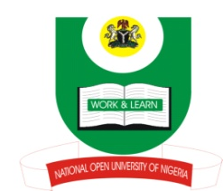
NATIONAL OPEN UNIVERSITY OF NIGERIA
14-16 AHMADU BELLO WAY, VICTORIA ISLAND, LAGOS
SCHOOL OF ARTS AND SOCIAL SCIENCES
JUNE/JULY 2013 EXAMINATION

COURSE CODE: PCR 833
COURSE TITLE: ETHNIC CONFLICT AND RESOLUTION
TIME ALLOWED:3HRS
INSTRUCTIONS: ANSWER ANY THREE QUESTIONS.

- With reference to Nigeria, examine the focal points of ethnic insurgency.(23mks)

- How true is it that colonialism created ethnicity in Africa? (23mks)

- What are the central issues in ethnicity? (23mks)

- Describe the nature of peacekeeping. (23mks)

- Identify and discuss three vital ingredients of ethnicity. (23mks)

(1Mark for good expression)

