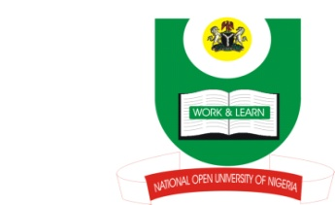
NATIONAL OPEN UNIVERSITY OF NIGERIA
14-16 AHMADU BELLO WAY, VICTORIA ISLAND, LAGOS
SCHOOL OF ARTS AND SOCIAL SCIENCES
JUNE/JULY 2013 EXAMINATION

COURSE CODE: PCR873
COURSE TITLE: ARMS CONTROL AND DE-MILITARIZATION
TIME ALLOWED: 3HRS
INSTRUCTIONS: ANSWER ANY THREE QUESTIONS

- What are multilateral processes in conflict resolution? Discuss the techniques and instruments of Disarmament? (23mks)

- What are Arms? Discuss the effects of Arms in conflict areas of the world in the 21st century? (23mks)

- Disarmament and Globalization have implications for global peace and security. Discuss. (23mks)

- With detailed examples, discuss five causes of armament globally? (23mks)

- What are Small Arms? Describe the features of Small Arms and outline five of the weapon-types? (23mks)

(1Mark for good expression)

