

**NATIONAL OPEN UNIVERSITY OF NIGERIA**

**University Village, NnamdiAzikiwe Expressway, Plot 91, Cadastral Zone, Jabi, Abuja**

**FACULTY OF SCIENCES**

**Department of Pure and Applied Science**

**JANUARY 2018 EXAMINATION QUESTIONS**

**COURSE CODE: PHY301**

**COURSE TITLE: CLASSICAL MECHANICS II**

**COURSE UNIT: 3 units**

**TIME: 3 HOURS**

ANSWER QUESTIONS ONE AND ANY FOUR OTHER QUESTIONS

1. a) Define the term ‘**Degree of freedom’** (2 marks)

b) Give **2** examples each of:

(i) single degree of freedom, (2 marks)

(ii) two degrees of freedom (2 marks)

(iii) infinite degrees of freedom (2 marks)

c) In a rotating coordinate system, x = rCos(wt + $θ$), y = rSin(wt + $θ$).

Show that T = ½ (mṙ2 + mr22) + mr2w + ½ mr2w2(4 marks)

d) What are generalized coordinates? (2 marks)

e) Write the transformation equation(s) for a change of a Cartesian

coordinate induced from changes in generalized coordinates in

terms of (i) **q** and (ii) ***dt*** (4 marks)

f)A disk of mass M is constrained to roll down an inclined plane without

slipping. Solve the Lagrange equations for motion. **Fig. 1**

­ (4 marks)

2. a) Show that in generalized coordinate, the kinetic energy for a system of N particles can be expressed as $$T=\sum_{K=1}^{3N}{\frac{1}{2}}A_{Kl}\dot{q_{k}}\dot{q_{l}}+\sum_{K=1}^{3N}{B_{K}}q_{K}+ T_{0}$$

(6 marks)

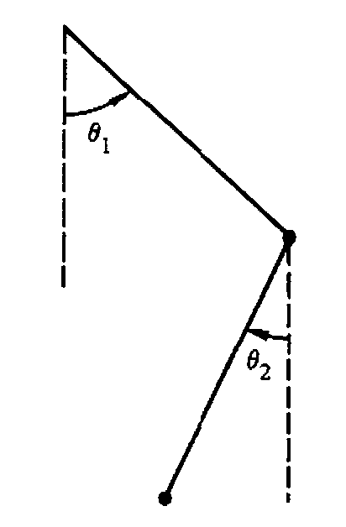and hence, the total energy.

b) In terms of generalized coordinates, the virtual work of **Fi**is $$\sum_{i}{F_{i}}.δr_{i}= \sum_{j}{Q_{j}}.δq_{j}$$ 
 Show that the generalized force **F** can be expressed as

$$Q_{j}= \sum_{j}{F_{i}}.\frac{δr_{i}}{δq_{j}}$$

**Fig. 2**

(6 marks)

3. (a) What are constraints? (2 marks)

(b) Define the following mechanical systems and give examples of each:

(i) Scleromic systems

(ii) Rheonomic systems

(iii) Holonomic systems

(iv) Non-holonomic systems

(v) Conservative and

(vi) Non-conservative systems (6 marks)

b) Set up a Lagrange’s equation for this Harmonic **Fig. 3**

Oscillators (A spring – mass system,shown in **Fig. 3** (4 marks)

4. a) Set up a Lagrange’s equation for the following Harmonic Oscillators

(i) A system of double pendulum in**Fig. 2** (4 marks)

(ii) An Atwood machine in **Fig. 4** and (4 marks)

(iii) A bead sliding on a rotating wire in**Fig. 5** (4 marks)

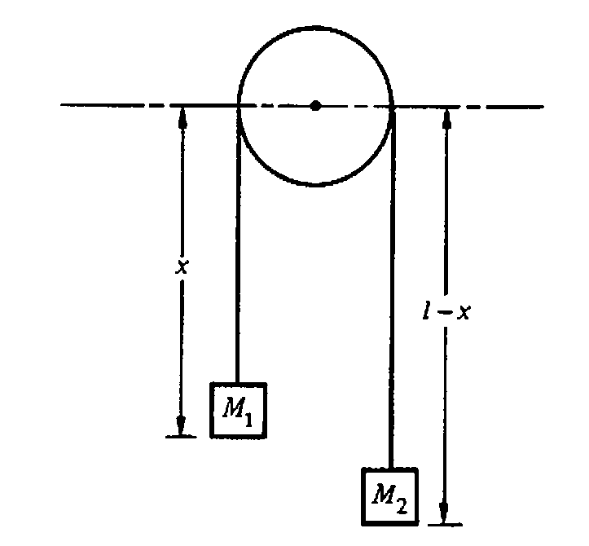

y

y = bx2

x

**Fig. 4 Fig. 5**

5.a) Write the equations of constraints describing eachof the following mechanicalsystems:

i) Holonomic,

(ii) Non-honolomic,

(iii) Scleronomic

(iv) Rheonomic (4 marks)

b) In **Fig 6,**a pendulum is attached to a massless

rim of radius **a** that rotates at a constant angular

velocity**ω**. (i) Obtain the Lagrange equation for

mass**m** for this system. (8marks )

6. a) State (i) Kepler’s first law, (ii) Kepler’s second law (iii) Kepler’s third law.

(b) If point **O** is the focus, the line AB is called a directrix and the ratio ϵ is the eccentricity. Show that the curve described by a point **P** in the plane of **O** in polar coordinates **(r,θ)** is $r= \frac{P}{1+cosθ}= \frac{a(1- e^{2})}{1+e\cos{f}}$