NATIONAL OPEN UNIVERSITY OF NIGERIA
UNIVERSITY VILLAGE, PLOT 91 CADASTRAL ZONE, NNAMDI AZIKIWE EXPRESS WAY,
JABI - ABUJA.
FACULTY OF SCIENCES
DEPARTMENT OF PURE AND APPLIED SCIENCE
JULY 2018 EXAMINATIONS

COURSE CODE: CHM 391
COURSE TITLE: PRACTICAL CHEMISTRY V – INORGANIC AND ANALYTICAL
COURSE UNIT: 2
TIME: 2 HOURS
INSTRUCTION: Question one is compulsory. Answer question one and any other
three questions.
QUESTION ONE

1ai) Write briefly on the principle of Atomic Absorption Spectroscopy. 6 marks
1aii) List the kind of compounds that are capable of absorbing UV-Visible radiation. 3marks
1aiii) Among the compounds listed in (1aii) above, which of them strongly absorb UV-Visible radiation or absorb UV-Visible radiation the most. 1 mark
1bi) Below is a table of values obtained for the determination of total alkalinity in a water sample, use this table to calculate the total alkalinity of a 100 ml water sample titrated with 0.02 M H₂SO_{4.}
NO of titration | Volume of sample (mL) | Initial burette reading | Final burette reading | Volume of Sulphuric (mL)
1 | 100 | 0.00 | 8.50 | 8.50
2 | 100 | 0.00 | 8.30 | 8.30
3 | 100 | 0.00 | 8.30 | 8.30
5 marks

1bii) Mention the indicators used to detect the presence of the following sources of alkalinity in water samples.
- OH⁻
- HCO³⁻ 2 marks
1biii) Give two significance and application of alkalinity. 2 marks
1ci) Outline the experimental procedure of how to determine the functional groups present in an organic sample. 5 marks
1cii) What kind of molecules absorb infrared radiation. 1 mark

QUESTION TWO
2a) In an experiment to determine the concentration of lead in soil collected from the side of a road using atomic absorption spectrophotometer, standard lead solutions were prepared and the absorbance of each solution measured. The data below was obtained
Standard solutions | Concentration (ppm) | Absorbance
Blank | 0.00 | 0.00
Standard 1 | 1.00 | 0.17
Standard 2 | 2.00 | 0.34
Standard 3 | 3.00 | 0.48
Standard 4 | 4.00 | 0.65
Standard 5 | 5.00 | 0.83

If the absorbance of the road side soil sample was 0.58, determine the concentration of lead in the soil sample from a calibration curve prepared by you. 13¹/₂ marks
2b) Mention one use of atomic absorption spectroscopy (AAS). 1¹/₂ marks

QUESTION THREE
In an experiment to determine the acidity of a water sample, the burette was filled with 0.02M NaOH, 100 ml of the water sample was transferred to a conical flask using pipette and few drops of methyl orange indicator was added to the content in the conical flask. The sample was titrated against the 0.02M NaOH solution until the orange colour became faint. The volume V₁ consumed for this titration was noted. To the same solution in the conical flask few drops of phenolphthalein indicator was added and the titration continued until the colour changed to faint pink colour. The total volume V₂ consumed for this titration was noted. The experiment was repeated three times to get concordant values.
The values obtained are presented in table 1 and 2. Use these values to calculate:

- The Mineral Acidity of the water sample
- Total Acidity of the water sample

Table 1 for Mineral Acidity
NO of titration | Volume of sample (mL) | Initial burette reading | Final burette reading | Volume of NaOH (mL)
1 | 100 | 0.00 | 0.50 | 0.50
2 | 100 | 0.00 | 0.40 | 0.40
3 | 100 | 0.00 | 0.40 | 0.40

Table 2 for Total Acidity
NO of titration | Volume of sample (mL) | Initial burette reading | Final burette reading | Volume of NaOH (mL)
1 | 100 | 0.00 | 2.20 | 2.20
2 | 100 | 0.00 | 2.30 | 2.30
3 | 100 | 0.00 | 2.30 | 2.30
The molecular weight of CaCO₃ = 100g (=100,000mg) 15 marks

QUESTION FOUR
4a) Identify the functional groups present in the infrared spectrum given below using the table of characteristic infrared absorption bands of organic functional groups provided below.
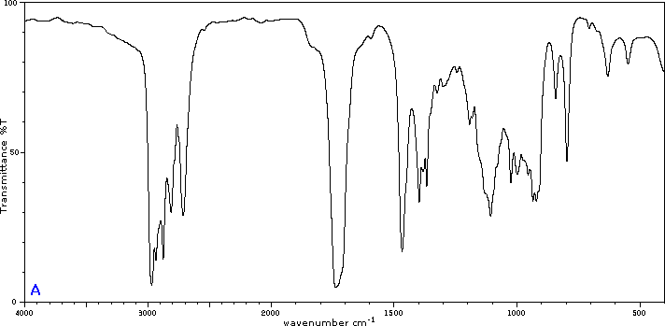

CHARACTERISTIC INFRARED ABSORPTION BANDS OF FUNCTIONAL GROUPS
Class of compounds | Absorption cm⁻¹ | Intensity | Assignment
Alkanes and Akyls  Alkenes  Alkynes  Ethers  Aldehydes  Carboxylic acids  Alcohols | 2850 – 3000  1450 – 1470  1370 – 1390  1365 +1395  Two bands  715 - 725  3020-3140  1640-1670  910+990  Two bands  885-895  665-730  960-980  790-840  3265-3335  2100-2140  610-700  2190-2260  1085-1150  1020-1075 and  1200-1275  (Two bands)  2700-2725  1720-1740  1685-1710  1100  2500-3500  1710-1715  1680-1710  3300 – 3400  1125 - 1205 | s  s  m  m  w  w-m  vw-m  m+s  s  m-s, broad  s  s  s  m  s  vw-w  s  m  m  s  s  m  s bend  s, broad  s, broad  s, broad  m - s | C – H stretch  C- H bend  CH_{2,} C – H bend  -CH(CH₃)₃ bend  -(CH₂)n bend  =C-H Stretch  C=C Stretch  =C-H bend  =C-H bend  =C-H bend  =C-H bend  =C-H bend  =C-H Stretch  C=C Stretch  =C-H bend  C=C Stretch  C-O-C Stretch  =C-O-C sym and asym stretch  H-C=O Stretch  C=O Stretch  C=O Stretch  C-C-C bending  O-H Stretch  C=O Stretch  C=O Stretch  O – H stretch  C –O stretch

Intensity abbreviations: vw = very weak, w = weak, m = medium, s = strong, vs = very strong
12 marks
4b) In what way is potentiometric titration different from classical titration. 3 marks

QUESTION FIVE

5a) The concentration of an organic compound is to be determined using UV-visible spectrophotometer, if the wavelength of maximum absorption (λ max) of this organic compound is unknown, use the information provided below to obtain the wavelength of maximum (λ max) at which the determination will be carried out.

Absorbance(s) of the organic compound | Wavelengths of absorption of the organic compound (nm)
0.100 | 360
0.110 | 380
0.120 | 400
0.125 | 420
0.130 | 440
0.160 | 460
0.165 | 480
0.400 | 500
0.60 | 520
1.00 | 540
1.10 | 560
0.80 | 580
0.40 | 600
0.10 | 620
0.11 | 640
0.12 | 660
12 marks
5b) In what way is potentiometric titration different from classical titration. 3 marks

