NATIONAL OPEN UNIVERSITY OF NIGERIA
Plot 91, Cadastral Zone, Nnamdi Azikiwe Expressway, Jabi, Abuja

FACULTY OF SCIENCES

APRIL, 2019 EXAMINATIONS

Course Code: CIT322
Course Title: Introduction to Internet Programming
Credit Units: 3 units
Time Allowed: 2½ Hours
Instruction: Answer Question 1 and any other Four (4) questions

1a) Outline the major steps involved in utilising the Common Gateway Interface. (8 marks)
1b) In a tabular form, distinguish between web client and web server. (8 marks)
1c) Give an extensive explanation of the term “Cloud Computing”. (6 marks)

2a) Discuss the following terms:
i) “Intranet” (3 marks)
ii) “Extranet” (3 marks)
2b) List four examples of broadband connections that can be used to access the Internet
(2 marks)

2c) Draw a well-labelled diagram of a web application. (4 marks)

3a) The diagram that follows shows the interconnectivity of networked-based devices and
operations, identify and name the devices labelled as of A, B, C, D (2 marks)

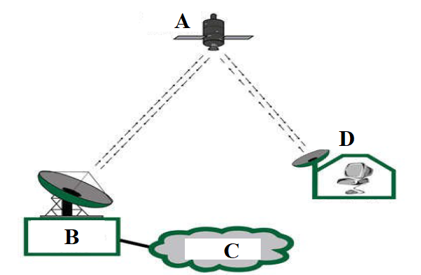
3b) Discuss extensively the terms:
i) “WWW” (5marks)
ii) “Email” (5 marks)
4a) Briefly describe the following types of computer networks:
(i) LAN (1½ marks)
(ii) WAN (1½ marks)
(iii) MAN (1½ marks)
4b) Define the purpose Cascading style sheets (3 marks)
4c) List the three types of Cascading Style Sheets (1½ marks)
4d) Explain the concept of Internet Protocol with respect to packets and headers transmission
(3 marks)

5a) In the following network model, identify the components labelled as A, B, C, D, E (5 marks)

B
A
C
D
E

5b) Define the use of Hypertext Reference (href) (2 marks)
5c) Explain the following video media types of files: (4 marks)
- .swf files
- .wmv files
- .mov files
- .mpeg files

5d) List any two (2) types of audio file format. (1 mark)

6a) Enumerate eight (8) types of servers (4 marks)
6b) List in the correct order , from layer 1 to layer 7, the layers of the Open System Interconnect model (4 marks)
6c) State the meaning of the following HTML tags (4 marks)
(i) <A>
(ii) <BR>
(iii) <HN>
(iv) <OL>

